Origami Master Screen Description

I. Flow Screen
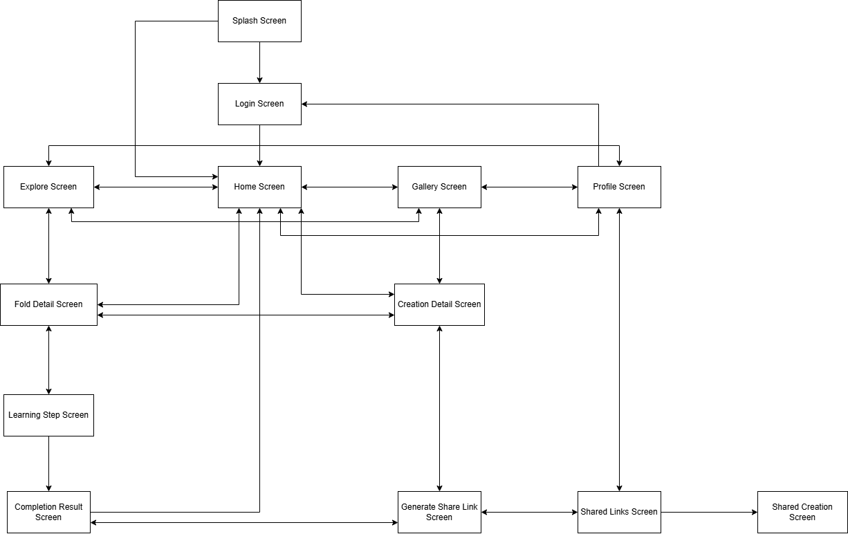

II. Screen Description

1. Splash Screen
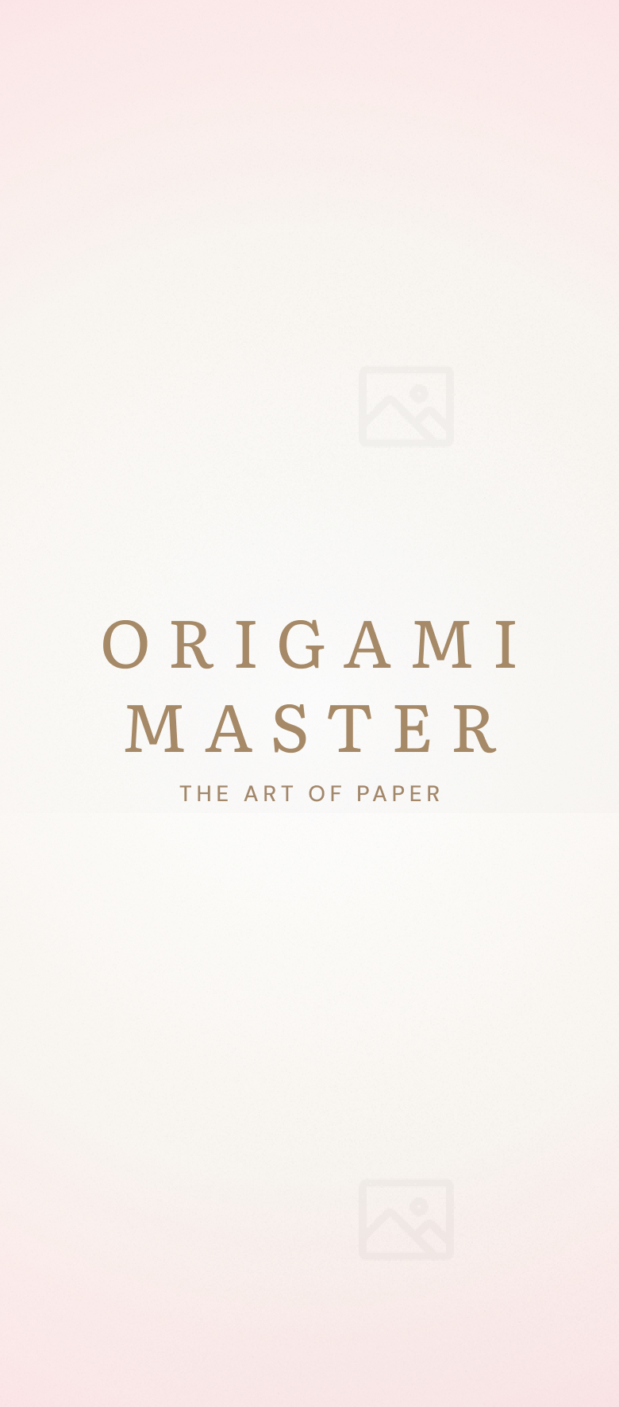

1.1. Purpose
The Splash Screen serves as the application entry point. Its purpose is to initialize local data, image assets, and application resources while checking whether the user has a valid saved login session. Based on the session status, the system redirects the user to either Home Screen or Login Screen.

1.2. UI Component
Section | Component | Data Type | Description
Body | App Name | Label | Displays the application name.

1.3. User Flow
- The user opens the application.
- The system displays the Splash Screen.
- The system initializes local data, image assets, and application resources.
- The system checks whether a valid login session exists.
- If the session is valid, the user is redirected to Home Screen.
- If the session is missing or expired, the user is redirected to Login Screen.

1.4. Navigation Flow
Action | Destination
Valid session detected | Home Screen
No valid session | Login Screen

2. Login Screen
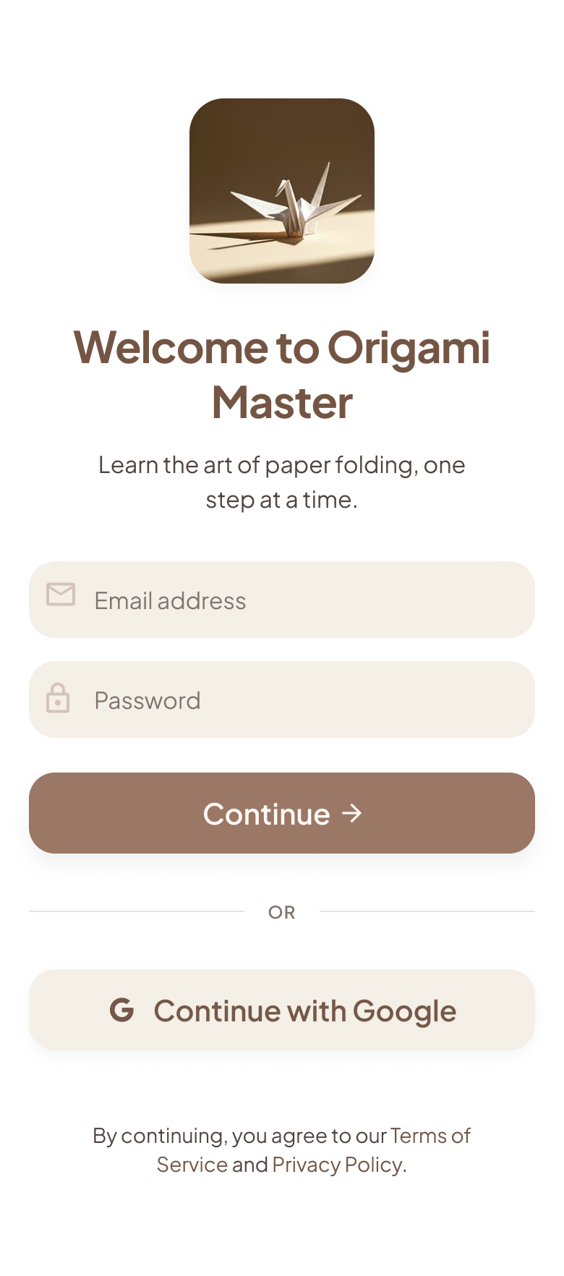

2.1. Purpose
The Login Screen allows users to authenticate before accessing the main features of Origami Master. Users can sign in using their email and password or continue with a supported external authentication provider. After successful authentication, the system saves the login session and redirects the user to Home Screen.

2.2. UI Component
Section | Component | Data Type | Description
Header | App Logo | Image | Displays the application identity.
Body | Welcome Text | Label | Introduces the Origami Master experience.
Body | Email Input | Text Field | Allows the user to enter an email address.
Body | Password Input | Password Field | Allows the user to enter a password securely.
Body | Continue Button | Primary Button | Submits the email and password login information.
Body | Google Login Button | OAuth Button | Authenticates the user with a Google account.
Footer | Terms Text | Label | Displays the application terms and privacy notice.

2.3. User Flow
- The system renders the Login Screen interface.
- The user enters email and password or chooses Google login.
- The user taps Continue or Continue with Google.
- The system validates the authentication information.
- If authentication succeeds, the system stores the session and redirects the user to Home Screen.
- If authentication fails, the system displays an error message and remains on Login Screen.

2.4. Navigation Flow
Action | Destination
Login successful | Home Screen
Google login successful | Home Screen
Login failed | Login Screen

3. Home Feed Screen

3.1. Purpose
The Home Feed Screen serves as the primary social hub of Origami Master. It displays origami creations published by followed users and recommended creators. Users can discover new creations, interact with posts, follow creators, and engage with the community through a continuously scrolling social feed.

3.2. UI Component
Section | Component | Data Type | Description
Header | App Logo | Image | Displays the application identity.
Header | Profile Avatar | Image Button | Opens Profile Screen.
Body | Featured Fold Card | Card | Displays a highlighted origami lesson.
Body | Continue Learning Card | Card | Shows the unfinished lesson and current step progress.
Body | Recent Community Creations | Horizontal Card List | Shows recently published creations from community users.
Bottom | Bottom Navigation Bar | Navigation | Provides access to Home, Explore, Gallery, and Profile.

3.3. User Flow
- User opens Home Feed Screen.
- System loads posts from followed users.
- System loads recommended posts.
- User scrolls through the feed.
- User may like, comment, or follow creators.
- User may open a post or creator profile.

3.4. Navigation Flow
Action | Destination
Tap Post | Fold Detail Screen
Tap Creator | User Profile Screen
Tap Comments | Comments Screen
Tap Explore tab | Explore Screen
Tap Gallery tab | Gallery Screen
Tap Profile tab | Profile Screen

4. Explore Screen
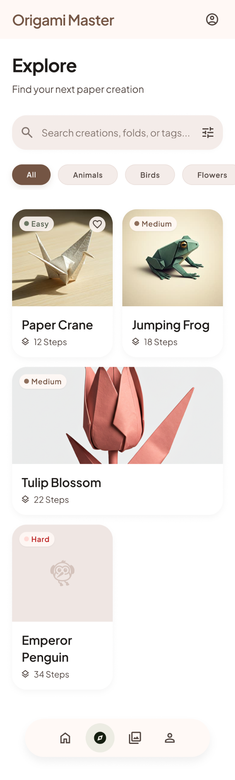

4.1. Purpose
The Explore Screen allows users to browse, search, and filter available origami models. Users can find models based on category, difficulty, estimated completion time, or model name before opening the corresponding Fold Detail Screen.

4.2. UI Component
Section | Component | Data Type | Description
Header | Search Bar | Text Input | Searches origami models by name.
Filter | Category Chips | Horizontal List | Filters models by Traditional, Animals, Flowers, Geometric, or Advanced.
Filter | Difficulty Filter | Filter Chips | Filters models by Easy, Medium, or Hard.
Body | Origami Grid | Grid List | Displays matching origami models.
Body | Fold Card | Card | Shows the fold image, name, category, duration, and difficulty.
Bottom | Bottom Navigation Bar | Navigation | Provides access to Home, Explore, Gallery, and Profile.

4.3. User Flow
- The user opens Explore Screen.
- The system loads origami models from the local database.
- The user enters a search keyword or selects category and difficulty filters.
- The system updates the origami grid based on the selected filters.
- The user taps a fold card to view its full information.

4.4. Navigation Flow
Action | Destination
Tap fold card | Fold Detail Screen
Use search | Explore Screen with filtered results
Tap category or difficulty chip | Explore Screen with filtered results
Tap Home tab | Home Screen
Tap Gallery tab | Gallery Screen
Tap Profile tab | Profile Screen

5. Fold Detail Screen
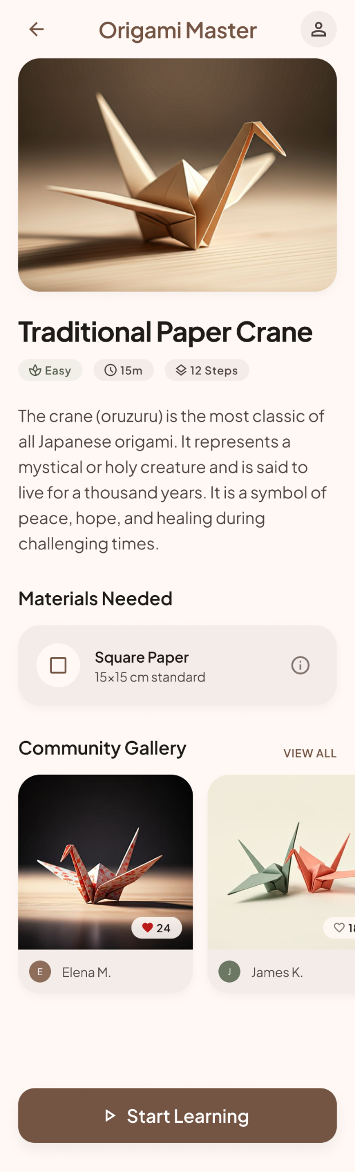

5.1. Purpose
The Fold Detail Screen provides complete information about a selected origami model. It displays the model description, difficulty, estimated time, required materials, step overview, and public community creations associated with the same origami model. Users can start the folding tutorial from this screen.

5.2. UI Component
Section | Component | Data Type | Description
Header | Back Button | Icon Button | Returns to the previous screen.
Hero | Fold Image | Image | Displays the completed origami model.
Info | Fold Title | Label | Displays the origami model name.
Info | Category Label | Label | Displays the model category.
Info | Difficulty Badge | Badge | Displays the difficulty level.
Info | Estimated Time | Label | Displays the estimated folding duration.
Materials | Material List | List | Shows required paper size, paper type, and optional tools.
Steps | Step Preview | Timeline | Shows an overview of the tutorial steps.
Community | Community Gallery | Horizontal/Grid List | Shows public creations whose OrigamiId matches the selected model.
Footer | Start Learning Button | Primary Button | Starts or resumes the folding tutorial.

5.3. User Flow
- The user opens Fold Detail Screen from Home or Explore.
- The system displays the selected fold information, materials, difficulty, duration, and step preview.
- The system loads community creations where IsPublic is true and OrigamiId matches the selected fold.
- The user may open a public community creation for a read-only detail view.
- The user taps Start Learning to begin or resume the tutorial.

5.4. Navigation Flow
Action | Destination
Tap back button | Home Screen or Explore Screen
Tap Start Learning | Learning Step Screen
Tap community creation | Creation Detail Screen

6. Learning Step Screen
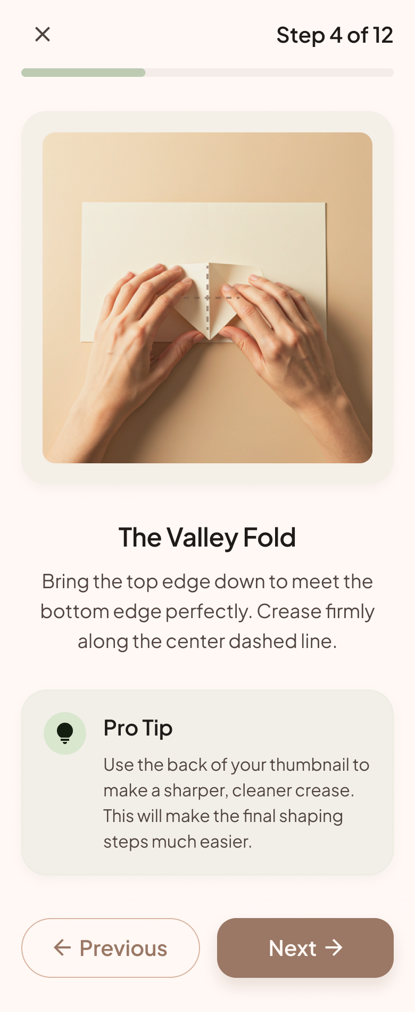

6.1. Purpose
The Learning Step Screen guides users through the origami folding process one step at a time. It presents instructional images, descriptions, progress information, and navigation controls that allow users to move between tutorial steps until the origami model is completed.

6.2. UI Component
Section | Component | Data Type | Description
Header | Close Button | Icon Button | Exits the tutorial session and returns to Fold Detail Screen.
Header | Step Counter | Label | Displays the current step number and total number of steps.
Header | Progress Indicator | Progress Bar | Shows tutorial completion progress.
Body | Instruction Image | Image | Displays the folding instruction for the current step.
Body | Step Title | Label | Displays the current folding action.
Body | Step Description | Text Block | Explains how to perform the folding action.
Body | Pro Tip Card | Card | Shows helpful tips for difficult folds.
Footer | Previous Button | Button | Moves to the previous tutorial step.
Footer | Next Button | Primary Button | Moves to the next tutorial step or completes the tutorial on the final step.

6.3. User Flow
- The user starts or resumes the tutorial from Fold Detail Screen.
- The system loads the first incomplete step or the currently saved step.
- The user follows the instruction image and description.
- The user taps Previous or Next to move between tutorial steps.
- The system saves the current step progress after navigation.
- On the final step, the system opens Completion Result Screen.

6.4. Navigation Flow
Action | Destination
Tap close button | Fold Detail Screen
Tap Previous | Previous step on Learning Step Screen
Tap Next | Next step on Learning Step Screen
Tap Next on final step | Completion Result Screen

7. Completion Result Screen
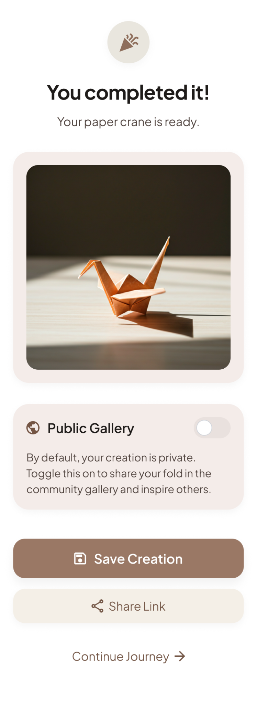

7.1. Purpose
The Completion Result Screen allows users to review and save their completed origami creation after finishing all tutorial steps. Users can upload a creation image, choose whether the creation remains private or is published to the Community Gallery, generate a private share link, and continue to another section of the application.
New creations are private by default. A creation appears in the Community Gallery only when the user enables the public visibility option.

7.2. UI Component
Section | Component | Data Type | Description
Header | Completion Title | Label | Displays a successful lesson completion message.
Body | Completed Fold Image | Image | Shows the completed origami result or uploaded creation photo.
Body | Completion Summary | Card | Displays the fold name, completion date, and time spent.
Body | Visibility Setting Card | Card | Allows the user to choose whether the creation is public or private.
Body | Publish to Community Toggle | Switch | Controls community visibility and is turned off by default.
Body | Visibility Description | Info Text | Explains that public creations appear in Community Gallery while private creations remain personal.
Footer | Save Creation Button | Primary Button | Saves the creation and selected visibility setting to the personal gallery.
Footer | Generate Share Link Button | Button | Saves the creation if needed and opens Generate Share Link Screen.
Footer | Continue Journey Button | Text Button | Returns the user to Home Screen after saving.

7.3. User Flow
- The user completes the final tutorial step.
- The system marks the origami lesson as completed and opens Completion Result Screen.
- The visibility option is Private by default.
- The user may enable Publish to Community to make the creation public.
- The user taps Save Creation and the system stores the creation in the personal gallery.
- If the creation is public, it can appear in Community Gallery for the same OrigamiId.
- If the creation is private, it remains hidden from Community Gallery but can still be shared by link.
- The user may generate a private share link or return to Home Screen.

7.4. Navigation Flow
Action | Destination
Tap Save Creation | Gallery Screen
Tap Generate Share Link | Generate Share Link Screen
Tap Continue Journey | Home Screen

8. Gallery Screen
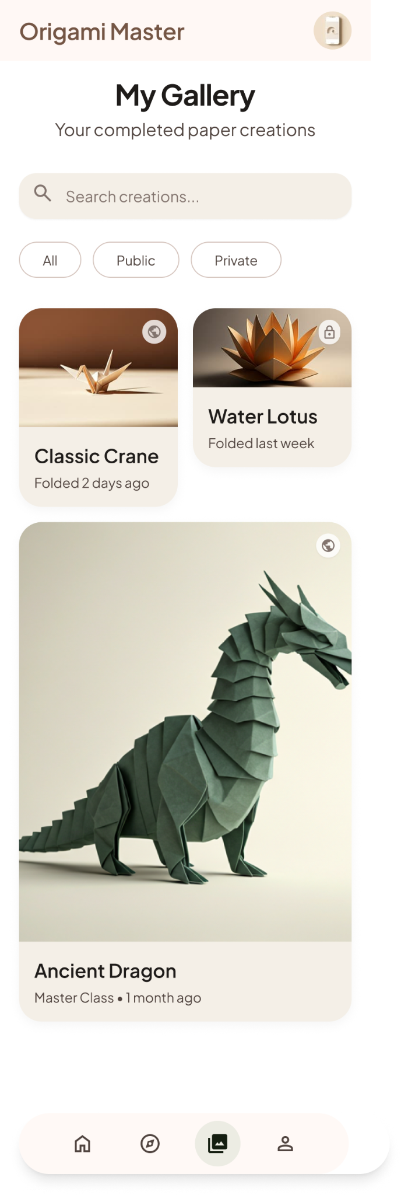

8.1. Purpose
The Gallery Screen allows users to manage and review their completed origami creations. It displays both public and private creations belonging to the current user and provides search and filtering options based on origami model, visibility, or completion date.

8.2. UI Component
Section | Component | Data Type | Description
Header | Screen Title | Label | Displays My Gallery or My Creations.
Header | Search Bar | Text Input | Searches the current user's creations by fold name.
Filter | Fold Type Filter | Filter Chips | Filters creations by model, category, or visibility.
Body | Creation Grid | Grid List | Displays completed creations belonging to the current user.
Body | Creation Card | Card | Shows creation image, fold name, completion date, and visibility status.
Bottom | Bottom Navigation Bar | Navigation | Provides access to Home, Explore, Gallery, and Profile.

8.3. User Flow
- The user opens Gallery Screen.
- The system loads all completed creations belonging to the current user.
- The user searches or filters creations by model, category, or visibility.
- The system updates the creation grid.
- The user taps a creation card to view its full details.

8.4. Navigation Flow
Action | Destination
Tap creation card | Creation Detail Screen
Tap Home tab | Home Screen
Tap Explore tab | Explore Screen
Tap Profile tab | Profile Screen

9. Creation Detail Screen
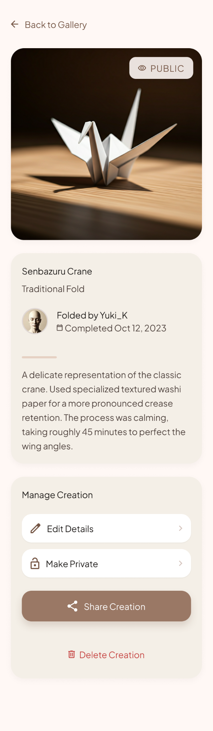

9.1. Purpose
The Creation Detail Screen displays complete information about a selected completed creation. It shows the creation image, related origami model, creator information, completion date, difficulty, and visibility status.
When the creation belongs to the current user, the user can update its visibility, generate a private share link, or delete the creation. Community creations are displayed in read-only mode.

9.2. UI Component
Section | Component | Data Type | Description
Header | Back Button | Icon Button | Returns to the previous screen.
Hero | Creation Image | Image | Displays the completed origami photo.
Hero | Visibility Status Badge | Badge | Displays the current visibility status, such as Public or Private.
Body | Fold Name | Label | Shows the related origami model.
Body | Creator Avatar | Image | Displays the profile image of the creation owner.
Body | Creator Nickname | Label | Shows the creator for community creations.
Body | Completion Date | Label | Shows when the origami was completed.
Body | Creation Description | Text Block | Displays the creator’s note or description about the completed origami.
Body | Edit Details Button | List Button | Opens the interface for editing the creation name, category, description, or related information.
Body | Change Visibility Button | List Button | Changes the creation visibility between Public and Private. The button label reflects the available action, such as “Make Private” or “Make Public.”
Body | Share Creation Button | Primary Button | Opens Generate Share Link Screen to create or manage a private share link.
Body | Delete Creation Button | Text Button | Opens a confirmation dialog before permanently deleting the creation.

9.3. User Flow
- The user selects a creation from Gallery, Home community section, or Fold Detail Community Gallery.
- The system displays the creation image and related information.
- If the creation belongs to the current user, the system displays visibility status and the Share Creation button.
- If the creation belongs to another user, the screen is read-only and does not show editing or sharing controls.
- The owner may tap Share Creation to generate a private share link.

9.4. Navigation Flow
Action | Destination
Tap back button | Gallery Screen, Home Screen, or Fold Detail Screen
Tap Share Creation | Generate Share Link Screen

10. Generate Share Link Screen
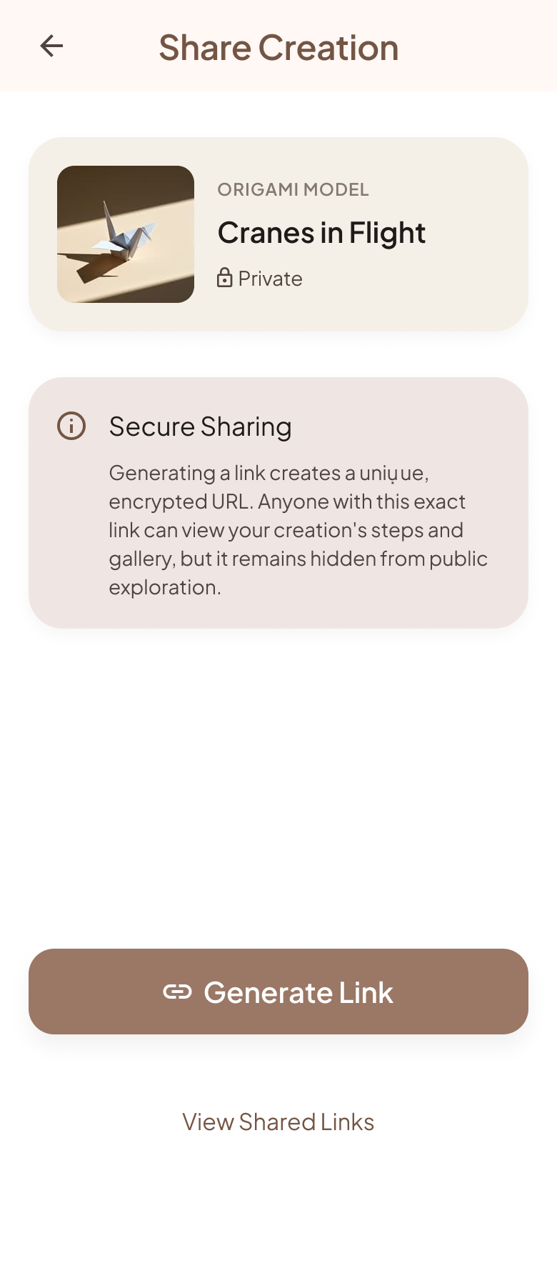

10.1. Purpose
The Generate Share Link Screen allows users to create a private link for a selected origami creation. The generated link can be shared externally and allows anyone who possesses the valid link to view the creation, even when the creation is marked as private.

10.2. UI Component
Section | Component | Data Type | Description
Header | Back Button | Icon Button | Returns to the previous screen.
Body | Creation Preview | Image Card | Displays the selected creation.
Body | Privacy Notice | Info Card | Explains that only people with an active link can view the shared creation.
Body | Generated Link Field | Read-only Text Field | Displays the generated share URL.
Footer | Generate Link Button | Primary Button | Creates and stores a unique private share link.
Footer | Copy Link Button | Button | Copies the generated URL to the clipboard.
Footer | View Shared Links | Text Button | Opens the list of active and disabled shared links.

10.3. User Flow
- The user opens Generate Share Link Screen from Completion Result or Creation Detail.
- The system displays the selected creation preview.
- The user taps Generate Link.
- The system creates a unique active link and stores it in Shared Links.
- The generated URL is displayed in the link field.
- The user may copy the URL or open Shared Links Screen.

10.4. Navigation Flow
Action | Destination
Tap back button | Completion Result Screen or Creation Detail Screen
Tap Generate Link | Generate Share Link Screen with generated URL
Tap Copy Link | Generate Share Link Screen with copied confirmation
Tap View Shared Links | Shared Links Screen

11. Shared Links Screen
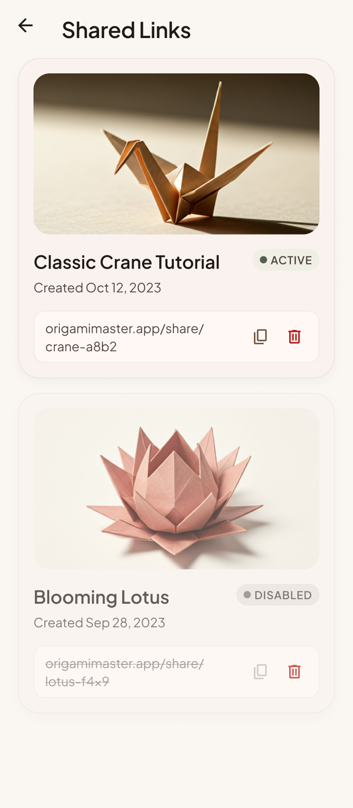

11.1. Purpose
The Shared Links Screen allows users to view and manage all private links generated for their creations. Users can copy an existing link, open its shared creation, or disable the link to prevent further access.

11.2. UI Component
Section | Component | Data Type | Description
Header | Back Button | Icon Button | Returns to Profile Screen or Generate Share Link Screen.
Header | Screen Title | Label | Displays Shared Links.
Body | Shared Link List | List | Shows all generated links belonging to the current user.
Body | Shared Link Card | Card | Displays creation preview, creation name, generated date, and active status.
Action | Copy Button | Icon Button | Copies an active share link.
Action | Delete Button | Icon Button | Disables or removes the selected share link.

11.3. User Flow
- The user opens Shared Links Screen from Profile or Generate Share Link Screen.
- The system loads all generated share links.
- The user may copy an active link, open a shared preview, or delete a link.
- When a link is deleted, the system marks it inactive and prevents future access.
- The list refreshes to show the updated link status.

11.4. Navigation Flow
Action | Destination
Tap copy link | Shared Links Screen with copied confirmation
Tap delete link | Shared Links Screen with link disabled confirmation
Tap shared link item | Shared Creation Screen
Tap back button | Profile Screen or Generate Share Link Screen

12. Shared Creation Screen
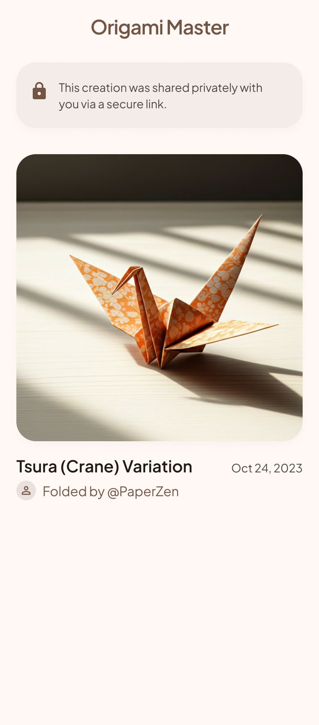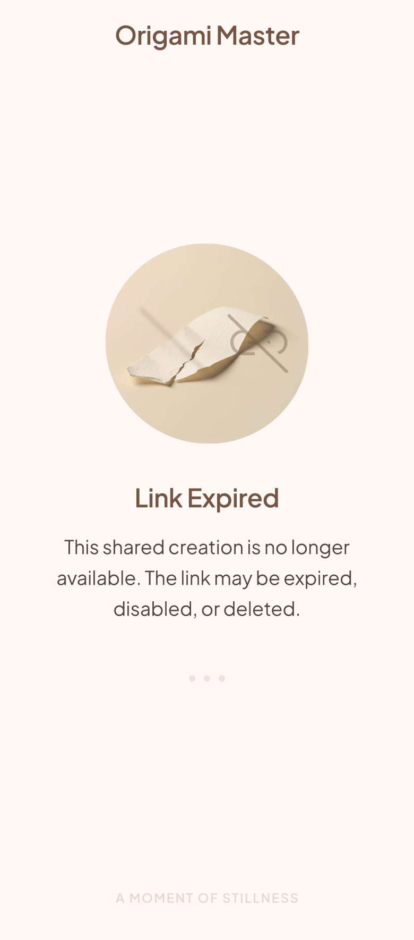

12.1. Purpose
The Shared Creation Screen provides a read-only view of an origami creation accessed through a private share link. The system validates the link before displaying the shared creation.
If the link is active, the viewer can see the creation information. If the link has been deleted, disabled, or is invalid, the system displays a link unavailable state.

12.2. UI Component
Section | Component | Data Type | Description
Header | App Name | Label | Shows Origami Master branding.
Body | Shared Creation Image | Image | Displays the shared origami creation.
Body | Fold Model Name | Label | Shows the related origami model.
Body | Creator Nickname | Label | Shows the creator display name.
Body | Completion Date | Label | Shows the completion date.
Body | Read-only Notice | Info Text | Indicates that the viewer cannot edit the shared creation.
Body | Unavailable Link State | Status View | Displays an expired or deleted link message when validation fails.

12.3. User Flow
- A viewer opens the shared URL.
- The system validates the share token and active status.
- If the link is valid, the system displays the creation in read-only mode.
- If the link is invalid, expired, or deleted, the system displays the unavailable link state.
- The viewer cannot change visibility, delete the creation, or generate another link.

12.4. Navigation Flow
Action | Destination
Open valid link | Shared Creation Screen
Open invalid, expired, or deleted link | Link Expired / Not Found State

13. Profile Screen
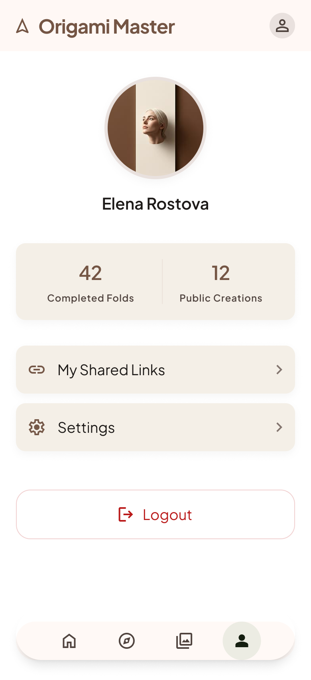

13.1. Purpose
The Profile Screen allows users to view and manage their personal account information and application preferences. It displays the user's profile information, completed creation statistics, and provides access to shared links, notification settings, appearance settings, privacy options, and logout functionality.

13.2. UI Component
Section | Component | Data Type | Description
Header | Avatar | Image | Displays the user profile image.
Header | Username | Label | Displays the user display name.
Body | Completed Folds Count | Label | Displays the number of completed origami lessons.
Body | Public Creations Count | Label | Displays the number of creations published to Community Gallery.
Body | Shared Links Button | Button | Opens Shared Links Screen.
Body | Settings Button | Button | Opens application settings or local preferences.
Body | Logout Button | Button | Ends the current login session and returns to Login Screen.
Bottom | Bottom Navigation Bar | Navigation | Provides access to Home, Explore, Gallery, and Profile.

13.3. User Flow
- The user opens Profile Screen.
- The system loads profile information and creation statistics.
- The user may open Shared Links or Settings.
- The user may log out of the application.
- The user can navigate to Home, Explore, or Gallery using the bottom navigation bar.

13.4. Navigation Flow
Action | Destination
Tap Shared Links | Shared Links Screen
Tap Settings | Settings Screen / Preference Dialog
Tap Logout | Login Screen
Tap Home tab | Home Screen
Tap Explore tab | Explore Screen
Tap Gallery tab | Gallery Screen

Updates to Origami Master App

3. Home Feed Screen (Updated from Home Screen)

3.1 Purpose
The Home Feed Screen serves as the primary social hub of Origami Master. It displays origami creations published by followed users and recommended creators. Users can discover new creations, interact with posts, follow creators, and engage with the community through a continuously scrolling social feed.

3.2 UI Component
Section | Component | Data Type | Description
Header | App Logo | Image | Displays Origami Master branding.
Header | Search Button | Icon Button | Opens content search.
Body | Feed List | Infinite List | Displays social feed posts.
Body | Feed Post Card | Card | Displays creation image, creator, and interaction statistics.
Body | Creator Avatar | Image | Displays post creator profile image.
Body | Creator Username | Label | Displays creator username.
Body | Creation Image | Image | Displays published origami creation.
Body | Fold Model Name | Label | Displays associated origami model.
Body | Like Count | Label | Displays total likes.
Body | Comment Count | Label | Displays total comments.
Action | Like Button | Button | Likes or unlikes a post.
Action | Comment Button | Button | Opens comments for the selected post.
Action | Follow Button | Button | Follows or unfollows the creator.
Bottom | Bottom Navigation Bar | Navigation | Provides access to Home, Explore, Gallery, and Profile.

3.3 User Flow
- User opens Home Feed Screen.
- System loads posts from followed users.
- System loads recommended posts.
- User scrolls through the feed.
- User may like, comment, or follow creators.
- User may open a post or creator profile.

3.4 Navigation Flow
Action | Destination
Tap Post | Post Detail Screen
Tap Creator | User Profile Screen
Tap Comment | Comments Screen
Tap Explore Tab | Explore Screen
Tap Gallery Tab | Gallery Screen
Tap Profile Tab | Profile Screen

NEW SCREEN – Post Detail Screen

Purpose
The Post Detail Screen provides a detailed view of a published origami creation. Users can review the full content, view comments, and interact with the post.

UI Component
Section | Component | Data Type | Description
Header | Back Button | Icon Button | Returns to Home Feed Screen.
Body | Creation Image | Image | Displays the published creation.
Body | Creator Information | Profile Summary | Displays creator avatar and username.
Body | Fold Model Name | Label | Displays related origami model.
Body | Description | Text | Displays creator description.
Body | Like Count | Label | Displays total likes.
Body | Comment List | List | Displays post comments.
Action | Like Button | Button | Likes or unlikes the post.
Action | Add Comment Field | Input | Allows users to submit comments.

NEW SCREEN – User Profile Screen

Purpose
The User Profile Screen allows users to view public information about another creator, follow them, and browse their published origami creations.

UI Component
Section | Component | Data Type | Description
Header | Back Button | Icon Button | Returns to previous screen.
Header | Avatar | Image | Displays creator avatar.
Header | Username | Label | Displays creator username.
Body | Followers Count | Label | Displays follower count.
Body | Following Count | Label | Displays following count.
Body | Public Creations Count | Label | Displays total published creations.
Action | Follow Button | Button | Follows or unfollows the creator.
Body | Published Creation List | List | Displays creator public creations.

NEW SCREEN – Comments Screen

Purpose
The Comments Screen displays all comments associated with a post and allows authenticated users to participate in discussions.

UI Component
Section | Component | Data Type | Description
Header | Back Button | Icon Button | Returns to previous screen.
Header | Screen Title | Label | Displays Comments.
Body | Comment List | List | Displays all post comments.
Body | Comment Item | Card | Displays commenter and comment content.
Footer | Comment Input | Input | Allows comment submission.
Footer | Send Button | Button | Posts a new comment.

8. Completion Result Screen (UPDATE)

Thêm UI Component
Section | Component | Data Type | Description
Action | Publish To Feed Toggle | Toggle | Determines whether the completed creation will be published to the social feed.

User Flow (Bổ sung)
- The user completes an origami lesson.
- The system saves completion information.
- The user chooses whether to publish the creation to the social feed.
- If Publish To Feed is enabled, the system creates a feed post.
- The user may generate a share link.
- The user may return to Home Feed or Gallery.

11. Gallery Screen (UPDATE)

Purpose
The Gallery Screen stores and manages creations belonging only to the current user. Both public and private creations are displayed here regardless of publication status.

UI Component (Thêm)
Section | Component | Data Type | Description
Body | Visibility Filter | Filter | Filters Public and Private creations.

13. Creation Detail Screen (UPDATE)

UI Component (Thêm)
Section | Component | Data Type | Description
Body | Feed Status Badge | Badge | Indicates whether the creation has been published to the social feed.
Action | Publish To Feed Button | Button | Publishes a private creation to the social feed.
Action | Remove From Feed Button | Button | Removes a published creation from the social feed.

16. Profile Screen (UPDATE)

UI Component
Thay thế: Private Creations Count bằng: Public Creations Count
Section | Component | Data Type | Description
Body | Completed Folds Count | Label | Displays completed origami lessons.
Body | Public Creations Count | Label | Displays creations published to the social feed.

Navigation Flow (UPDATE)

Splash
↓
Login
↓
Home Feed
├─ Post Detail
│ └─ Comments
├─ User Profile
├─ Explore
├─ Gallery
└─ Profile

Explore
└─ Fold Detail
└─ Learning Step
└─ Completion Result

Completion Result
├─ Publish To Feed
├─ Gallery
└─ Generate Share Link

Gallery
└─ Creation Detail
└─ Generate Share Link

Profile
├─ Shared Links
├─ Settings
└─ Logout

Shared Links
└─ Shared Creation

